Anatomy of a B.U.M.
Bum Marketing Made Easier/Faster
By Paul Evans

http://nicheology.com/1.htm

This Report is For Your Personal Use and Imagination Only

© Info Market Results

The purpose of this report is to help you:

Organize your BUM marketing or any marketing efforts to save you time and money so you can make more money.

Help you recognize the opportunities and possibilities you may be missing

Train yourself to create proprietary
processes and models.

Bum Marketing is one of the latest “crazes.” But there’s something that makes it different from the rest. Importantly different.

It’s based on the human element. It teaches you skills that you can use across the board of your online efforts. And while certain sites you’re using for promotion might shift in popularity, it’s relatively easy to find a new one.

Unlike the automated site generators, mass pinging, etc. Bum Marketing is based on the elements of business and SEO fundamentals. Things that won’t change with the next algorithm.

Bum Marketing has long term possibilities. If you’re willing to stick to the simple system of BM, then here are some ways to keep it organized, and ways to advance your personal BM system.

Here’s How to keep you B.U.M. clean…

Bookmark YOUR Process

book·mark (bk'märk') : to record the location (URL) of a favorite Web site to allow quick access in the future. To place a marker to quickly locate a needed reference or tool.

Take the time to bookmark EVERYTHING out in your Bum Marketing (BM) process ONCE. Links, templates, checklists, etc. Don’t waste time trying to locate a link, or hope that it is still in your browser memory.

Set up your:

- Favorites Folder in your browser. Include your links to your affiliate markets, online research tools, article directories, classified add directories, etc. Link them directly to the login page, not just the home page. Set them up numerically so you can work through them step, by step.
- Shortcuts folder on your desktop leading to your tools. This will keep you from getting lost in your software options and keep you using only what you need. Place a shortcut to EVERY tool you use on the folder.
- Website Templates. Lay a “beginning” site out and use it each time to rapidly make changes.
- Checklists. Step-by-step processes for each BM element. An article writing example is for you below. The reason for a checklist is it keeps you focused and on track.

All of this little things are HUGE time savers. Even though you know your process, sometimes it is difficult to remember what step you are in.

Here is the way I set mine up…

My Favorites Folder:

I am able to move through the necessary links in my system quickly. They are arranged in order so I click and go.

In addition to the basic BM links I also have my possibilities links. These are community sites, forums, and pages I have noticed ranking high in my keyword areas. Then there are my profit links, which let me login to PayPal, Clickbank, etc to check the daily gross receipts.

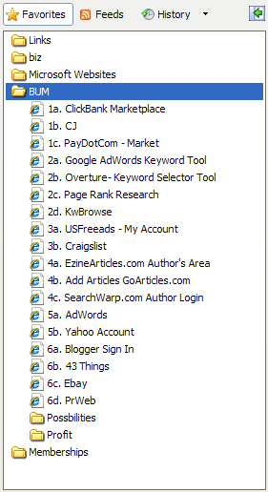

My Shortcuts:
Anything you need for research & development should be in a shortcut folder for easy access. I went from “searching” for which tool I was looking for in my programs menu…

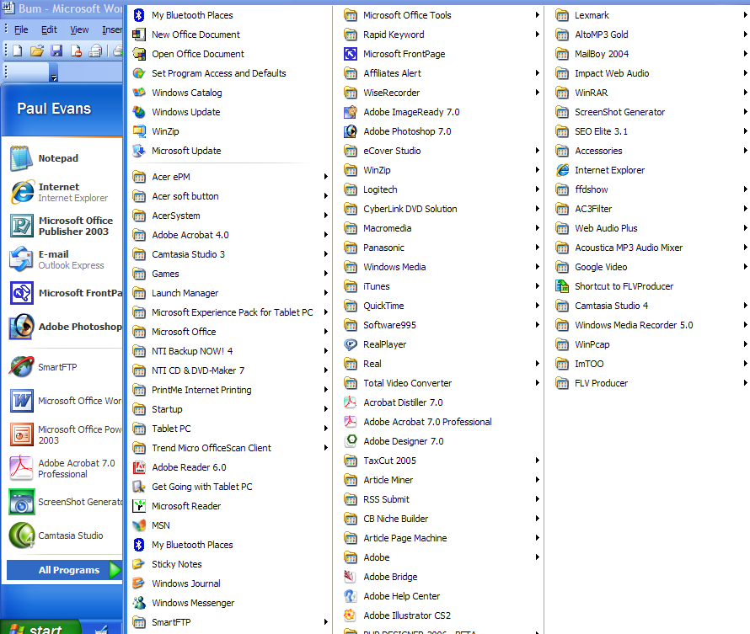

To this…

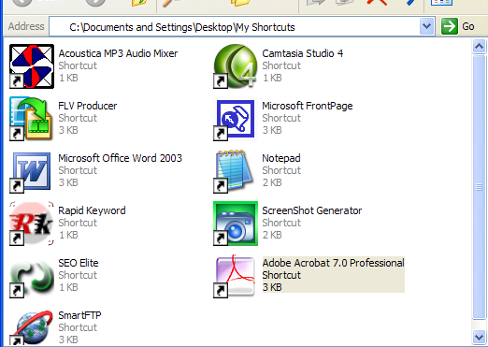

Only the software I use for BM is in this shortcut folder.

The easiest way to do this for those who may not be familiar is to:

- Create a folder on your desktop or and label it something like “BUM Shortcuts.”
- Click start and enter your programs area.
- Click and drag the tool you want into your BUM folder on your desktop.

My Templates:

Yes, I’m still using FrontPage! I use simple layouts so this works. However, the results I’m getting from XSitePro are doing well, so I may make the complete switch for my marketing sites.

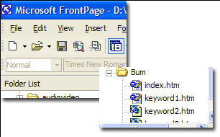

The template for each new site is already laid out. All I have to do is add info and change key words. XSitePro makes it easy to generate keyword related pages without them leaving the footprint of a page-gen software.

With each new site I just copy and paste the template into a new folder. I rename it to the keyword theme of the site.

MY Checklist:

Here’s my article writing checklist…

- Keyword title that grabs attention.
- List the 3-5 points or acrostic of importance.
- Two paragraphs per point
- 250-350 words total
- Linked keyword from within the article
- Linked from resource Box

Make your OWN checklists that work for you. I absolutely LOVE Jimmy D. Brown’s checklists that he creates for List and Traffic. Yep, it’s an aff. Link.

That same type of checklist development makes your repeated effort move smoother.

Unique YOUR P.L.A.N.

u·nique (yōō-nēk') adj. Without an equal or equivalent; unparalleled; Unusual; extraordinary.

Critical to your long-term success is a non-patterned approach. Relevant content sites will NEVER go out of style, so make yours YOUnique. There is no reason to use a page generation software (unless you’re linking them to competitors website and driving down their relevancy – not that I’m recommending it!).

Why? Because being too lazy can get you caught!

Mass content generation sites – caught!
Mass blogs – caught!
Mass pings – caught!
Same I.P.s – caught!
Duplicate content – caught!
Auto-building – caught!

YOU need to use the original BUM Marketing system as a STARTING point. That’s the beginning The lace to grow from. Then make your own P.L.A.N. to ensure that you are slightly different from other bums.

Pass on Predictability & Patterns = create relevant processes.

DON’T do what everyone else does. Add elements. Add ideas. Take previous knowledge and apply it in the a new way to BM. Doing what everyone else is doing will get you… caught!

- Use additional article directories.
- Post in high page ranking forums in your niches.
- Outsource to someone who does not know BM, but does know SEO.
- Read every thread in the Warrior Forum and see if there is a pattern to avoid. See how you could tweak what is being said to your benefit.

Create a model of operations that is YOURS. It does not have to be difficult or time consuming. The more streamlined the better. The more intuitive, the better. The less predictable, the better.

What is a model of operations? It’s like a launch sequence. Travis covers one in BM:

- Affiliate Product Research meeting certain criteria
- Keyword research meeting certain criteria
- Article Writing
- Site development
- Content Promotion
- Repeat

You can stick with those steps while only changing the WAYS you go about it. The tools you use. The place you promote your content. Applying the mechanics to your steps becomes your mode of operation.

Why does BM work so well? It’s HUMAN. Stuff done my hand has a great chance of succeeding. It communicates, “I’m real and here to stay.”

Learn from victory = multiply the principle.

Know success. Be able to recognize it. Not just $, but Traffic. Conversion. Sign-ups. Emails.

Be able to recognize what a win is for you and repeat it. Tweak it. What will a win look like for you?

- Getting ranked?
- Getting published?
- Completing the job?
- Locating a converting affiliate product?
- Traffic that is repeating?

Come to terms with what victory will be for YOU. Then begin to expand it.

There is too little celebration of success in Internet Marketing. Even if the project as a whole fails to meet expectation, determine what DID go right and learn from it.

FIRST: Capture the principle. A principle can be used across the board to build your business. The inability of people to recognize principles is the reason there are so many niches in the world.

I create and sell products for public speakers. The principles are the same across the board. The concepts and ideas are identical. But teachers want one resource, attorney’s another, and business owners another. They each THINK they have to have something with “their” name on it.

When we train ourselves to see principles instead of practices then we’ll stop saying “That wont work for me” to “I’m gonna be rich!!”

One principle I learned while doing this is… “Multiple Formats,” which has tuned into the “M” of this report. You’ll read more about it later.

SECOND: Capture the plays. When Paul Bear Bryant, famed coach of Alabama, began his coaching career he went to a friend and said, “I ain’t got any good plays. I need your playbook.”

Take the Warrior Forum and WSOs for example. There are a LOT of principles you can play off of mentioned in the forum, or that are subtly there.

Here’s one I learned and applied this week…

Josh Anderson already had his WSO going, then he posted this is the WF:

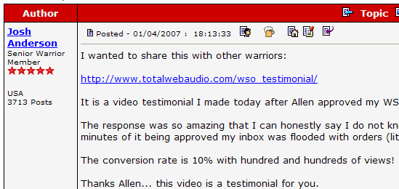

Not that he created it for this purpose, but the video didn’t just boost WSOs in general; it boosted Josh’s WSO. It sent traffic from the main forum to the WSO forum. Specifically HIS WSO, right?

I used this same play, but applied it to BM using Google video. I uploaded an existing video. Linked to a site and got traffic almost immediately. There have been a couple of sales today from this idea.

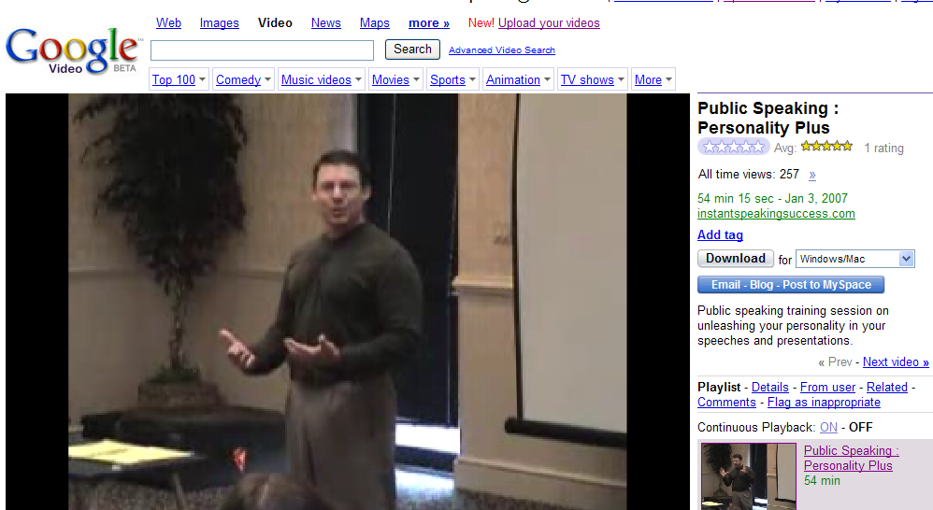

Don’t just read and post. Look for the principle within the play and USE IT!

(Side note: I have 8 measures I use in the Warrior Forum that tell me if a market or idea is worth pursuing in other areas. Also, they tell me WHY certain ones work for Warriors, but maybe not other people. If you’re interested in a WSO on this just email psevans@earthlink.net and let me know you be interested in me putting together my “8 Degrees of WF”)

Assess Regularly & Rapidly = cut losses.

Know your metrics…
- Traffic
- Conversion
- Number of times an article is viewed
- Number of views of a post
- Profit per hour (so you know what you’re worth and if you are wasting time).
- Time to completion of articles, sites, research, etc.

Listen!

You do NOT have to spend hours pouring over the numbers.

For example:

I look for a “primary” number on each site: the page that gets the most traffic. Then I connect the next highest traffic page to that page. I also put my most responsive affiliate product on that page.

So a five second look at traffic stats can tell me where I need to fine-tune my site layout.

Do that with all your numbers. If you really want to do some crunching, set side an afternoon and dedicate time to it, but don’t get so busy counting beans that you forget to plant them.

Never Tell Unless You Sell = make money off the process.

Have you ever wondered WHY people sell their “secrets”?

- It’s running out of time. Not as effective as it once was. They see the light at the end of the tunnel. Haven’t you noticed how quickly Adsense died once multiple page generation software hit the market? The guys using it KNEW it would be short lived.
- Want the praise of discovery. Have you seen the FedEx commercial where the guy made ONE right decision in a meeting then used that as his life-anchor? Some want this. They want the praise that comes with sharing something new and being smart.
- Nice. Believe it or not some guys. Some just want to help the “other team” out a bit. That’s what Travis has done with BM. Sure, he’s going to do some affiliate sales, but for the most part, he’s just a good guy looking to help.
- Money. They know the idea is good and won’t lose effectiveness. Relationship forged with those helped may create income down the road.

If you have some secrets you feel like sharing here’s what I’ve noticed: People argue, critique, and whine when FREE tips are shared. They see no value.

If you have VALUABLE information, then sell it. I’ve ordered dozens of WSOs and will gladly continue to pay for great ideas and concepts.

The Key: The reason this is part of your P.L.A.N. is that you should be creating some valuable processes. WORTH selling even if you give them away.

Multiply YOUR Formats & Formulas

mul·ti·ply ¹ (mŭl'tə-plī') to make many or manifold; increase the number, quantity, etc., of.

Begin thinking about the long term possibilities of your BM efforts.

Just this morning I was talking to a friend about BM and he was getting ready to write his articles. I mentioned, “Why don’t you write them in a way so you could eventually compile them into an ebook or report?”

Stealing a play from top7business.com, he could write nothing but lists of 7 for his niche. Thirty articles with lists of 7 could easily be compiled around the same theme.

From there he could multiply the information into various…

Formats

The information, if proven successful, could be repackaged into…
- Audio
- Video
- Reports
- PLRs
- Master Rights

Yes, all of those are OBVIOUS. It makes you want to throw-up since that list is nothing more than what you would get in a free mini-course. However, the average BM is making the process linear. They are following the plan, but not multiplying it.

Don’t stay linear!

Unless your linear looks like this…

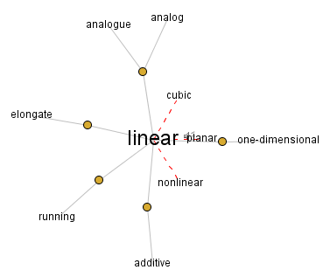

Otherwise, be multi-linear, so you can produce in all directions.

If you’re going to go to all the trouble to create these traffic munching sites, then multiply the results of your effort once you find out what works.

And once you find out what works create your…

Formulas

Here what match formulas look like:
Closure Property of Addition
Sum (or difference) of 2 real numbers equals a real number
Additive Identity
a + 0 = a
Additive Inverse
a + (-a) = 0
Associative of Addition
(a + b) + c = a + (b + c)
Commutative of Addition
a + b = b + a
Definition of Subtraction
a - b = a + (-b)

Heck, if math nerds can use formulas, why can’t we??

Once you discover the recipe that works for you, write it down. Be like Coca-Cola with your business. I broke that rule with the Google example above, but it’s so obvious, no big deal.

So the formula for the Google Video is:

Video + Google + Keyword Link = Target Traffic

Now then, once you have a base formula, tweak it. Sometimes you will come up with a Dr. Pepper and sometimes a New Coke.

Here’s a variation of the original formula:

Ezine Article Link + Google Vid + Keyword Link – Target Traffic

With that formula you’re testing to see if more people will visit a video than a webpage. You could have one article that lands on your site and one that lands at Google video.

Of course you may just want to put the video on one webpage and traditional content on another and test against the two from article based traffic.

Ultimately, I might distill the formula to this:

Keyword (google or overture tools) + Traffic Avenue (ezine articles, usfreeads) + Format (video, pdf, website, mp3)
+ Link = Target Traffic

You should have dozens of those types of little formulas. They are not hard to develop. All you do is take your specific element (overture, ezine articles) and make it generic (keyword tool, avenue, etc.) Then tie a combination of the elements to a desired result (traffic, sales, signups)

Formulas let you cook the same way every time. As one of my business partners stole from someone, “Never do anything great once. Do it time and time again.”

Once you have your formulas you can repeat great time and again!

SUMMARY:

Bookmark Your Process: Make it easy to access and use your tools. Create a step by step.

Unique Your P.L.A.N.: Create valuable sites that are based on your secrets.

Multiply Your Formats & Formulas: See the full range possibilities of your materials. Create formulas that let you repeat success.

There you have it! The Anatomy of a B.U.M. guaranteed to keep you regular and feeling fine!


http://nicheology.com/1.htm

